Regulations:
A18

H.T No

Sreenidhi Institute of Science and Technology
(An Autonomous Institution)
Code No: 7A304 Date: 16-Dec-2019 (FN)

B.Tech II-Year I-Semester External Examination, Dec-2019/Jan-2020 (Regular)
ELECTRICAL CIRCUITS AND NETWORKS – II (EEE)

Time: 3 Hours Max.Marks:70

Note: a) No additional answer sheets will be provided.
b) All sub-parts of a question must be answered at one place only, otherwise it will not be valued.
c) Missing data can be assumed suitably.

Part - A Max.Marks:20

Answer all QUESTIONS.

1. | Define symmetrical system and phase sequence. | [2M]
2. | What is the behavior of capacitance at t=0 and t=∞. | [2M]
3. | Define poles and zeros in a transfer function. | [2M]
4. | Write the symmetry and reciprocal conditions for Z, Y Parameters. | [2M]
5. | Discuss about the pass band, stop band and cutoff frequency. | [2M]
6. | Explain even symmetry of Fourier series. | [2M]
7. | Define active power and reactive power. | [2M]
8. | What is driving point in transfer function? Explain. | [2M]
9. | List the drawbacks of prototype filter. | [2M]
10. | Define line voltage and phase voltage. | [2M]

Part – B Max.Marks:50
ANSWER ANY FIVE QUESTIONS. EACH QUESTION CARRIES 10 MARKS.

11. | a) | Derive the relationship between a line current and phase current related to a delta connected load. | [5M]
 | b) | Two wattmeters in a 3-phase, 3-wire system with an effective line voltage of 120V read 1500W and 500W. What is the impedance of each arm of the balanced delta connected load? What is the power factor of the load? | [5M]
12. | a) | What is time constant? Explain time constant in case of series R-L and series R-C circuit. | [5M]
 | b) | An R-C series circuit with R=100Ω and C=100µF is energized by an alternating voltage 100sin100t V. Assuming zero initial charge, determine the current at t=0.02sec. after the switch is closed.  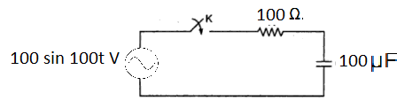 | [5M]
13. | a) | Write the necessary conditions for driving point function. | [5M]
 | b) | For the network shown in figure determine the transform impedance Z(s).  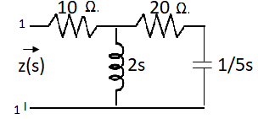 | [5M]
14. | a) | Define Z and Y parameters of a two port network and determine the relationship between the above parameters. | [5M]
 | b) | Determine h-parameters after writing transformed network.  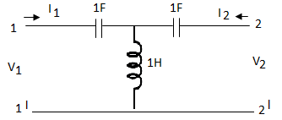 | [5M]
15. | a) | What is a high pass filter? In what respects it is different from a low pass filter? Explain. | [5M]
 | b) | Derive the equation to find the inductances and capacitances of a constant-K high pass filter. | [5M]
16. | a) | Determine the Fourier series for the half wave rectifier cosine function shown in figure.  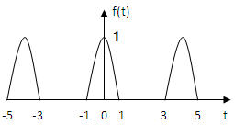 | [5M]
 | b) | Explain linearity, time scaling, convolution and time shifting properties of Fourier Transform. | [5M]
17. | a) | What are the advantages of a three phase system? | [3M]
 | b) | Find the current in a series R-L circuit having R=2Ω and L=10H while a DC. voltage of 100V is applied. What is the value of this current after 5 sec. of switching on? | [3M]
 | c) | Draw the pole zero diagram for the given network function I(s) and hence obtain i(t).  I(s) = | [4M]
18. | a) | The Z-parameters of a two port network are Z₁₁=20Ω, Z₂₂=30Ω, Z₁₂=Z₂₁=10Ω. Find Y and ABCD parameters of the network. | [4M]
 | b) | What are the demerits of m-derived filters? | [3M]
 | c) | What is half wave symmetry? Explain. | [3M]

-- 00 -- 00 –

